Inventing a pandemic

The WHO now says it did not endorse lockdowns. The record suggests otherwise — and points to a deeper pattern in how pandemics are framed.
Maryanne Demasi, PhD
Jan 28, 2026
∙ Paid
As the United States completes its withdrawal from the World Health Organization (WHO), the agency has begun telling a carefully edited version of its role in the Covid-19 pandemic.
The WHO now says it did not endorse lockdowns, insisting that national governments acted independently of its guidance.
But the public record suggests a different picture.
In the earliest and most consequential weeks of 2020, senior WHO officials publicly praised China’s unprecedented shutdown of Wuhan and other cities, describing the response as “bold,” “agile,” and “aggressive.”
Following a joint press conference with Chinese authorities, the WHO credited China’s sweeping actions — including city closures, travel bans and population-wide restrictions — with saving lives and “flattening the curve.”
The WHO’s director-general echoed these assessments, repeatedly applauding China for “setting a new standard” in responding to the outbreak.
In October 2020, it tweeted that sometimes lockdowns were “needed to swiftly suppress the virus and avoid health systems being overwhelmed”.

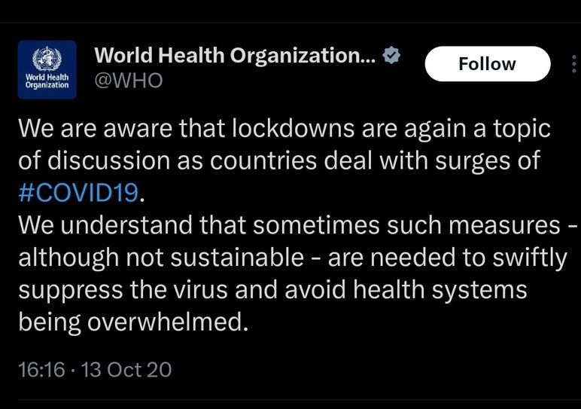

These were not neutral observations. They were value judgements, delivered by the world’s most influential public health authority at a moment of global panic.
The signal to governments was clear: this was what responsible pandemic control looked like.
Lockdowns were rapidly adopted in over 100 countries by March 2020.
The WHO’s advice may not have been legally binding, but it did legitimise a policy previously considered unethical and disproportionate in democratic societies.
Now, as the human, economic, and social costs of those policies become clear, the WHO is distancing itself from the very measures it once publicly praised.
Is it trying to rewrite history?
A group of German researchers say this is not new. More than a decade earlier, they accused the WHO of “inventing” a pandemic during the 2009 swine flu outbreak.

A warning from 2009
In 2009, during the swine flu outbreak, the WHO declared a global pandemic caused by a novel strain of H1N1 influenza.
The announcement triggered mass vaccination campaigns, emergency procurement contracts and billions of dollars in public spending across the developed world.
But the disease itself proved mild for the overwhelming majority of people. In many countries, the death toll was lower than that of an average seasonal flu.
In a 2011 article titled The Invention of the Swine Flu Pandemic, German researchers argued that the crisis was not driven by the clinical severity of the virus, but by institutional decisions made by global health authorities — particularly the WHO.
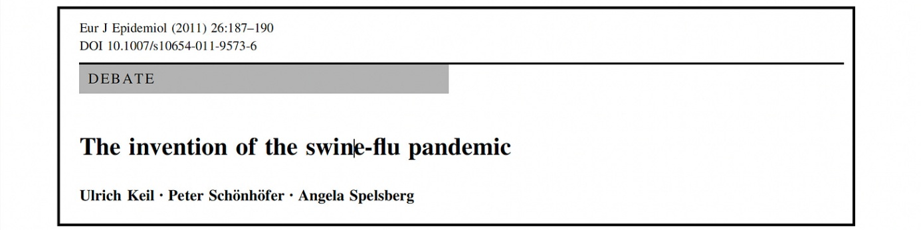

The authors described how pandemics can be constructed through lowered thresholds, speculative modelling and the amplification of worst-case scenarios.
Central to their critique was a quiet but consequential change made by the WHO just weeks before the pandemic was declared.
In May 2009, the organisation revised its definition of a pandemic, removing any requirement that a disease be severe or deadly. Geographic spread alone was now sufficient.
That definitional shift allowed the WHO to declare a level-6 pandemic on 11 June 2009, even though swine flu caused fewer deaths than a typical seasonal influenza outbreak.
In Germany, about 260,000 infections were recorded, with 258 deaths — a case fatality rate of roughly 0.1 per cent. Older adults, who are usually most vulnerable to influenza, were largely spared.
Yet the pandemic “label” unleashed panic rather than proportionality.
Germany spent more than €500 million purchasing 50 million vaccine doses. Fewer than seven million were ever used.
The authors argued this was not an accident, but the predictable outcome of an institutional culture that equated hypothetical risk with imminent catastrophe.
Speculative theories — such as the idea that mild viruses might suddenly mutate into lethal strains — were promoted by virologists and amplified by the WHO, creating what the paper described as “killer virus scenarios”.
None of those scenarios materialised.
SARS, avian flu and swine flu were all classified by the WHO as the most dangerous category of infectious threat. In reality, the authors concluded, they amounted to a succession of false alarms.
The consequences, however, were real.
Public funds were squandered, dissenting scientists were marginalised, and media outlets largely relayed official messaging without scrutiny. Conflicts of interest among scientific advisers went undisclosed.

The same script, played again
The parallels with Covid-19 are difficult to ignore.
During the swine flu episode, Poland was one of the few countries to resist pressure to purchase vaccines. It was criticised at the time, yet its outcomes were no worse than those of countries that complied fully.
A decade later, Sweden would play a similar role during Covid-19.
Sweden rejected prolonged lockdowns, keeping most schools, restaurants and businesses open. It endured fierce international criticism.
In June 2020, the WHO’s Regional Director for Europe criticised countries like Sweden that he claimed were experiencing “accelerated transmission” and risked overwhelming their health systems.
But Sweden’s chief epidemiologist, Anders Tegnell, rejected the alarm. In time, Sweden recorded outcomes that compared favourably with many peers — including lower excess mortality and far less social disruption.

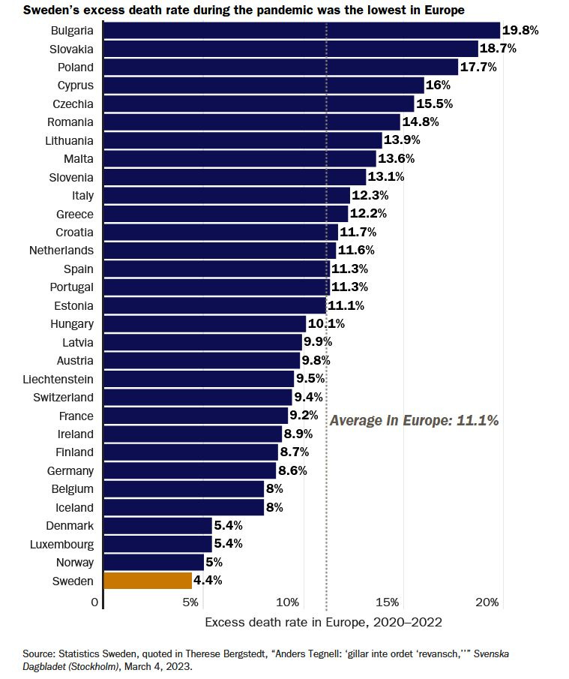

Power without accountability
The WHO does not need to issue binding orders to shape global policy.
Its influence lies in authority, framing and fear.
It lowers thresholds when convenient, amplifies uncertainty, and presents speculative risk as settled science. Governments respond — not to binding instructions — but to the weight of institutional endorsement.
These dynamics sit alongside powerful financial incentives.
The WHO’s increasing reliance on earmarked funding from governments and private actors has aligned its priorities more closely with pharmaceutical solutions, pandemic preparedness programs and emergency responses — approaches that benefit major commercial interests while sidelining more measured, evidence-based strategies.
Seen in this light, the swine flu episode was not merely a mistake. It was a warning.
The German authors concluded in 2011 that influenza angst campaigns had become “out of range and irresponsible”. From the vantage point of the Covid era, the swine flu affair looks less like an anomaly and more like a rehearsal.
When the curtain rose again in 2020, the same tools were deployed — only to be quietly disowned once the consequences became impossible to ignore.
The risk is not simply that history is being rewritten, but that responsibility and accountability is erased — allowing the cycle to happen again.
Will it?

